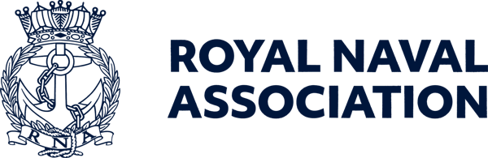

Semaphore Short Friday 18 September 2026

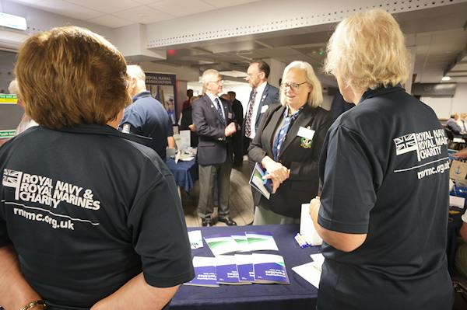

CONA delegates gather

More than 80 delegates attended the Conference of Naval Associations (CONA) meeting in Portsmouth last Friday to network and share their experiences and views of the current state of the Naval community.
RNA members, key stakeholders, Naval charities and industry partners – plus a renowned author – gathered at the Royal Maritime Hotel in Portsmouth to strengthen their network of contacts across the Naval sector.
Events such as CONA play an important role in supporting the RNA’s strategic aims by strengthening relationships across the Naval community, raising the profile of participating organisations and encouraging greater engagement among members and stakeholders.
One of the presentations was by Hugh Sebag-Montefiore, author of Battle of the Arctic, a detailed account of the Arctic Convoys which will be published in paperback in November – see the November edition of the Semaphore Circular for more details.
The Royal Naval Association would like to thank all speakers, delegates, volunteers and staff who contributed to the success of the event and looks forward to continuing the conversations and partnerships established during the day.

Remembrance and Comradeship Grants

Could your RNA Branch benefit from funding for a remembrance or comradeship activity?
Royal Navy & Royal Marines Charity (RNRMC) Remembrance and Comradeship Grants can help eligible RNA Branches and other Naval and Marines organisations fund activities that bring people together, support remembrance and strengthen comradeship, while helping to reduce loneliness and social isolation.
Funding can contribute towards:
* Remembrance and commemorative events
* Travel to national remembrance events
* Branch and community gatherings
* Venue hire, refreshments and promotion.
Your application should explain how the activity will benefit your community and help people connect with others and access support.
Find out more and apply: https://www.rnrmc.org.uk/remembrancegrants.



Uckers in the offing

It is now two weeks and counting until the World Uckers Championships in Portsmouth.
Hosted by the RNA at the Royal Maritime Hotel in Queen Street on Saturday 3 October, registration on the day will be held between 0900 to 1000, and players of any standard, from novice to expert, are welcome to enter the competitions.
The first roll of the dice will be at 0930, and spectators are most welcome at the event, which features both solo and pairs competitions.
There is still time to sign up, and organisers would welcome players representing ships and establishments, as well as RNA branches or areas.
To help us plan, please register your interest by emailing Milly at ceo-ea@rnassoc.org with your name, contact details and whether you're entering solo or with a teammate.

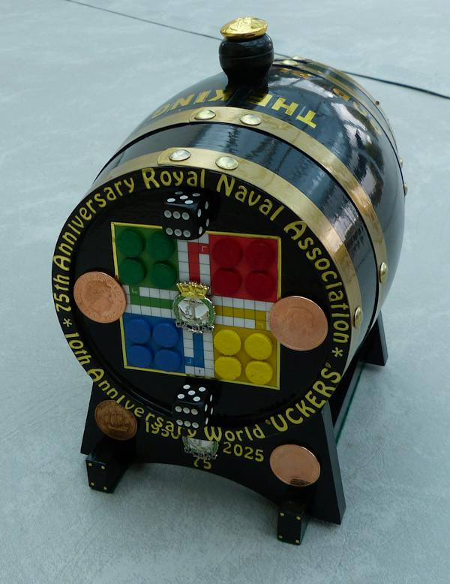

Roll out the barrel

And talking of the Championships, a unique rum barrel (pictured above) created by Shipmate Wally Blagden, is available through an auction which ends on the day of the competition, with bidding currently standing at £500.
Money raised will be donated to the RNA Central Charity Fund.
The current highest bidder, who wishes to remain anonymous, has expressed an interest in presenting the barrel to the Association to auction once more at a Trafalgar Night dinner.
The 2.5 litre barrel includes several special coins, including a King George VI 1950 halfpenny (representing the RNA’s 75 anniversary last year), a 1970 Galleon halfpenny (for the 56th anniversary of Black Tot Day), and a King Charles III 2026 £5 crown, marking 500 years of the crown coin.
Bidding will close on 3 October to coincide with the World Uckers Championships.
If you would like to make a bid, you can send it to RNA Central Office at ceo-ea@rnassoc.org and we will pass it on to Wally.

Action needed on Remembrance parade applications

All those who have registered to march with the RNA contingent in London in the Remembrance Sunday parade should by now have received an email from the Royal British Legion.
It is important that shipmates read that email and follow the instructions therein.
The deadline for participants to register with the Royal British Legion is Wednesday 30th September, and a number of shipmates who initially applied through the Association have not yet completed their registration form ahead of the deadline.
Registration after the deadline will not be possible as any unallocated tickets will be offered to ex-Service individuals.
There are still a small number of places available to join the RN contingent on the Sunday.
If you would like to march with fellow RNA Shipmates past the Cenotaph in Whitehall, please email Jon on ams@rnassoc.org as soon as possible.
And please remember that, following the parade, the RNA is hosting a sandwich lunch reception for 50 members at the Civil Service Club at 13-15 Great Scotland Yard, London SW1A 2HJ, but because of the limited number this will be strictly on a first-come, first-served basis.

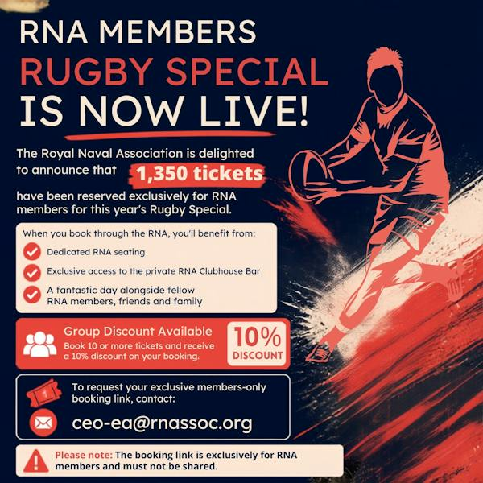

Army v Navy rugby tickets on sale

RNA members can now apply for tickets for the Army v Navy rugby double header at Twickenham on Saturday 1 May next year.
The Association has an allocation of 1,350 tickets exclusively reserved for RNA members. For 2027, tickets will be available through a dedicated
members-only booking link, which will be sent directly to members who request tickets.
Please note: To protect our allocation, this booking link must remain confidential and must not be shared with anyone else.
The RNA experience provides:
- A dedicated RNA seating
- Exclusive access to our private clubhouse bar.
Enjoy the day alongside fellow RNA members, friends and family.
The rugby kicks off at 1400 for the senior men’s clash, with the women’s match following at 1645.
If you are bringing a crowd, purchasers of ten or more tickets will receive a ten per cent discount on their booking.
Contact us to request your members-only booking link and secure your place before our allocation is exhausted.
Email Milly on ceo-ea@rnassoc.org

On the move

Just a reminder that the Central Office team has shut up shop at Lanyard House for the next few weeks, and will be working from a smaller office elsewhere in Portsmouth Naval Base or from home while essential maintenance is carried out on the building.
While interim communications are being established, email is the most effective way of reaching any particular member of staff.
You could also try ringing 07889 059025 during office hours if you urgently need to speak to someone.
Keep an eye on our social media channels and the Semaphore publications for further information on the maintenance programme and our return to Lanyard House.

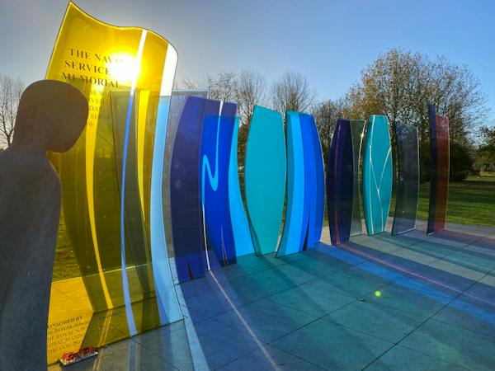

Fundraising continues for Naval Service Memorial

We are still seeking funds to help preserve and maintain the stunning Naval Service Memorial at the National Memorial Arboretum.
The appeal is aiming to raise £75,000 – £15,000 for essential repairs and £60,000 to cover future maintenance and upkeep costs.
Part of this will ensure the unique and stunning glass panel seals are updated to withstand the wear and tear of the Staffordshire weather using techniques which were not available at the time it was created 12 years ago.
Sadly, one of the memorial’s glass panes has developed water ingress at its upper edge. To prevent further deterioration and to protect the structure as a whole, remedial work is required to repair the affected pane and to install protective seals across all panes
The monument stands as a powerful tribute to the service and sacrifice of the Royal Navy, Royal Marines, and associated services.
We strongly encourage all those with an interest in Naval history, service, and remembrance to visit the National Memorial Arboretum, at Alrewas near Burton, and see the memorial for themselves.
Any contribution, large or small, will help ensure the Naval Service Memorial remains a fitting and dignified place of remembrance for all future visitors.
You can donate using this link: https://www.justgiving.com/campaign/navalservicememorial

RNA diaries go on sale

The Royal Naval Association 2027 diary is now on sale.
The diary costs £8.50 without postage, or £10 including postage and packing.
To order your copy please contact Jon B on ams@rnassoc.org or Kathryn on dams@rnassoc.org.

  Shop for the Association
  You could turn your everyday shopping into support for the RNA without spending an extra penny.
  Whether you're buying gifts, booking a holiday, or ordering your weekly essentials online, you could be raising free donations for the Royal Naval Association through easyfundraising.
  Simply sign up, select the RNA as your chosen charity, and participating retailers will donate on your behalf at no additional cost to you.
  It’s free to join, there are thousands
  

of retailers involved, and every donation helps support members, veterans, and their families
Start fundraising the easy way – use this link: https://tinyurl.com/54b34d42 or use the QR code (above right). You just need to click ‘Support this Cause’, create a free account, and start shopping with participating retailers via the website, app or browser extension.
Once you’re registered, donations will be automatically generated whenever you make eligible purchases.

 |  |  |  |  |  |  |  |  |  |  | 

